Example: The Role of a Business Analyst in an E-Commerce Project
Imagine a retail company wants to launch an online store where customers can browse products, add items to a shopping cart, pay online, and track deliveries.
The company hires a project team to build the e-commerce website. The Business Analyst (BA) ensures that the business requirements are understood, documented, communicated, and validated throughout the project.
1. The project scenario
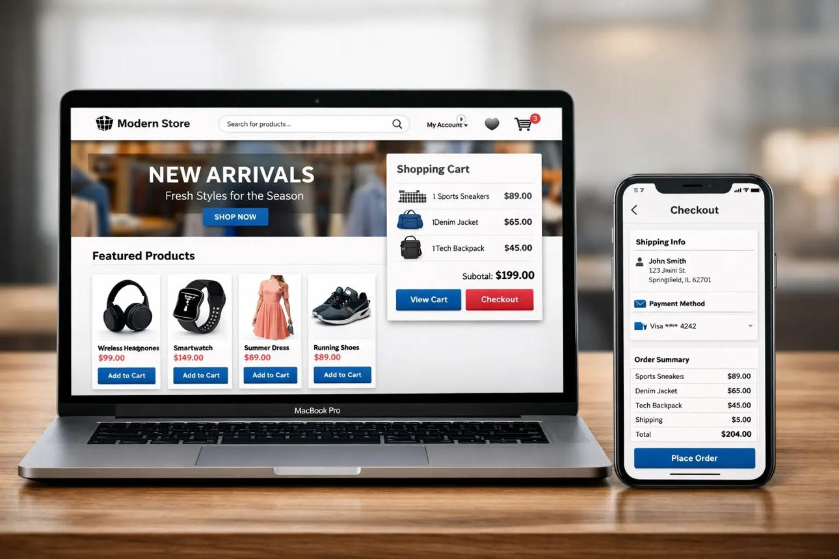
devimus.com
Online Store Project
Business objective
Increase sales by launching an online shopping platform.
Project duration
12 weeks (illustrative)
Main stakeholders
Business owner, sales team, marketing, warehouse, finance, customer service, developers, testers, and customers.
The project will include six main features:
- Product catalog and search.
- Customer registration and login.
- Shopping cart.
- Checkout and payment.
- Order confirmation and tracking.
- Inventory and order management.
2. What does the BA actually do?
Step 1: Understand the business requirements
The BA meets with the business owner and stakeholders to understand their needs.
For example, the business owner says:
“We want customers to buy our products online and pay by credit card.”
This is a starting point, not a complete requirement. The BA asks questions such as:
- Can customers purchase as guests, or must they register?
- Which payment methods are supported?
- How is product availability checked?
- What happens if a payment fails?
- What happens if an item becomes unavailable during checkout?
- How are shipping costs calculated?
- Can customers cancel an order?
BA deliverable: Business requirements and a clearly defined project scope.
Step 2: Analyze and document the requirements
The BA converts the answers into specific requirements the development team can implement and the testing team can verify.
Here are examples.
ID | Requirement | Priority
FR-01 | Customers can browse products and view prices. | Must have
FR-02 | Customers can add products to a shopping cart. | Must have
FR-03 | The system calculates the order total, including applicable taxes and shipping. | Must have
FR-04 | Customers can pay through an approved payment gateway. | Must have
FR-05 | Customers receive an order confirmation after a successful order. | Must have
FR-06 | Customers can view the status of their orders. | Should have
These are examples of functional requirements—descriptions of what the system must do.
The BA may also document non-functional requirements, such as performance, accessibility, security, and availability.
Step 3: Map the customer shopping process
The BA creates a process flow to show how customers move through the website and where decisions must be made.
STEP 1
Browse products
STEP 2
Select product and quantity
STEP 3
Add product to cart
STEP 4
Review cart and shipping details
STEP 5
Submit payment
STEP 6
Confirm order and update inventory
STEP 7
Send confirmation and arrange fulfillment
The BA also identifies alternative scenarios:
- If payment fails, the customer should see an error and be able to retry.
- If stock is insufficient, the customer should be informed before the order is accepted.
- If the payment succeeds but the order system fails, the system must handle the situation safely without charging the customer twice.
BA deliverable: Process flow diagrams, business rules, and exception scenarios.
Step 4: Write a user story and acceptance criteria
Suppose the development team is building the shopping cart.
The BA writes a user story that explains the feature from the customer's perspective.
User story
As an online shopper, I want to add a product to my shopping cart so that I can purchase it later.
Acceptance criteria
These criteria define how the team will determine whether the feature works correctly.
When a customer selects an available product and clicks Add to Cart, the product appears in the cart.
The cart displays the product name, unit price, quantity, and line total.
When the customer changes the quantity, the subtotal updates correctly.
The customer cannot add a quantity that exceeds the permitted available stock.
The BA discusses these criteria with the product owner, developers, and testers to ensure everyone has the same understanding before development begins.
Step 5: Work with the development team
During development, developers will have questions. The BA clarifies the business rules and documents decisions.
For example:
Developer: “What should happen if a customer adds five items to the cart, but only three are available?”
BA: “The system should not allow the customer to proceed with five units. It should display the available quantity and let the customer adjust the cart.”
The BA may also help evaluate proposed solutions, clarify requirements, and assess change requests.
The BA does not normally decide the technical architecture or write the application code unless those responsibilities are also part of their role.
Step 6: Support testing and UAT
When the developers finish a feature, the BA helps confirm that it meets the business requirements.
For example, for checkout, the BA might define these test scenarios:
Test scenario | Expected result
Successful payment | Order is created and confirmation is displayed.
Declined payment | Customer receives an appropriate message; the order is not marked paid.
Insufficient inventory | Customer cannot complete the order for unavailable quantities.
Invalid shipping address | Customer is prompted to correct the address.
Customer clicks Pay twice | Duplicate charges and duplicate orders are prevented.
The BA works with QA testers, reviews results, helps clarify defects, and supports User Acceptance Testing (UAT), in which business users verify that the solution meets their needs.
Step 7: Support launch and evaluate results
Before launch, the BA may help confirm that:
- Business requirements have been met.
- Critical defects have been resolved or formally accepted.
- Business users are prepared to use the system.
- Order, payment, inventory, and fulfillment processes work together.
- The business has a way to measure success.
After launch, the BA may help analyze metrics such as conversion rate, checkout abandonment, failed payments, and order-processing errors.
3. Who does what in the e-commerce project?
Activity | BA | PM | Developer | QA
Gather business requirements | Leads/supports | Coordinates | Consulted | Consulted
Define project schedule | Supports estimates | Leads | Provides estimates | Provides estimates
Document business rules | Leads | Informed | Consulted | Consulted
Build website features | Clarifies needs | Coordinates delivery | Leads | Supports
Execute testing | Clarifies expected results | Monitors progress | Fixes defects | Leads testing
Business acceptance | Supports and validates | Coordinates | Fixes issues | Provides evidence
The exact division of responsibility depends on the organization and delivery methodology.
4. What would the BA deliver during the 12-week project?
This is an illustrative timeline, not a mandatory sequence.
Weeks 1–2
Discovery and scope
Stakeholder interviews, business objectives, scope, initial requirements
Weeks 3–4
Requirements and design
User stories, acceptance criteria, process maps, business rules
Weeks 5–9
Development support
Requirement clarifications, backlog refinement, change analysis, decision log
Weeks 10–11
Testing and UAT
Test scenarios, requirement validation, defect clarification, acceptance support
Week 12
Launch readiness
Requirements traceability, outstanding issue review, operational handover support
In an Agile project, these activities overlap: the BA may analyze checkout requirements while the team is already developing the product catalog.
5. How can you tell whether the BA is doing a good job?
Consider a practical checkout example.
A weak requirement says:
“The checkout should be user-friendly.”
A stronger requirement says:
“The checkout must display the order subtotal, applicable taxes, shipping charges, and final payable amount before the customer submits payment.”
The second requirement is clearer and easier to implement and test.
A strong BA consistently helps the team answer three questions:
- What exactly does the business need?
- How should the system behave in normal and exceptional situations?
- How will we prove that the delivered solution meets the requirement?
In summary: In an e-commerce project, the BA connects business objectives to detailed requirements, supports the development team in implementing the right features, and helps verify that customers and the business can use the finished online store successfully.

